**Research**

**Resilience of the UK Food System in a Global Context**

  
GFS has launched a major interdisciplinary research programme “Resilience of the UK Food System in a Global Context” (GFS-FSR). Co-designed by funders and stakeholders, it aims to help policymakers and practitioners optimise the resilience of the UK’s food system to environmental, biological, economic, social and geopolitical shocks.

**Summary**

**The UK food system is vulnerable**

The UK imports around half of its food, and our diets are very varied demanding a wide range of foodstuffs to be available year round. Environmental, social, political and economic stresses interact to make the UK food system vulnerable to disruption. For example, extreme weather (an important aspect of climate change), conflict, currency fluctuations all affect crop production, logistics and trade. The effects of these food system ‘drivers’ (especially powerful when they occur together), lead to volatility in food supply and affordability.

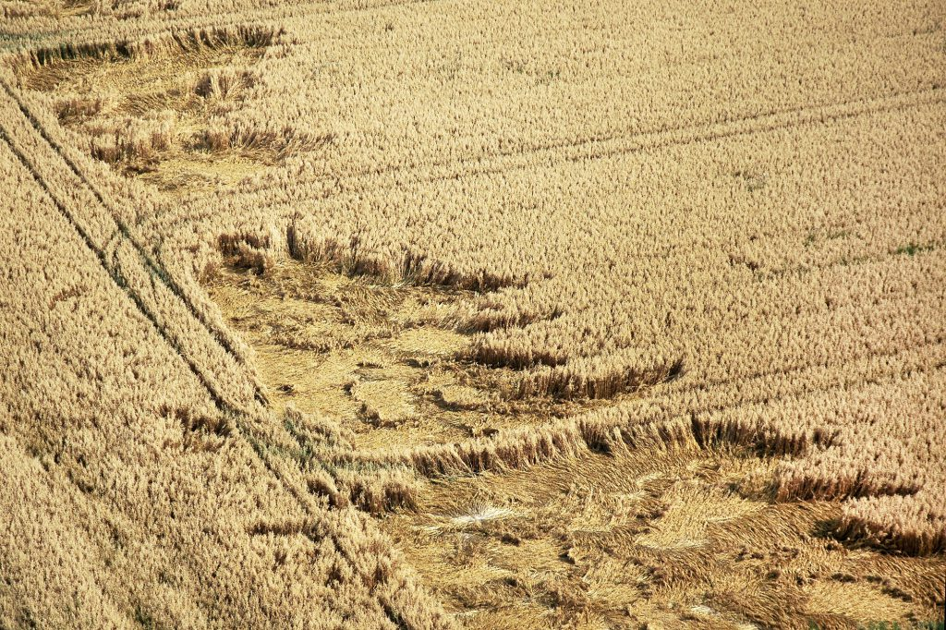miropink/Shutterstock.com

A corn field damaged by storm – an example of extreme weather disrupting food production.

**The UK food system is complex**

The UK food system involves many activities from producing and processing, to distributing and retailing food. All these activities are influenced by social, policy, technological, market, environmental and economic forces, trends and shocks. A change in any one activity has repercussions across the system, affecting food security, other socioeconomic and environmental goals, which feed back to food system drivers.

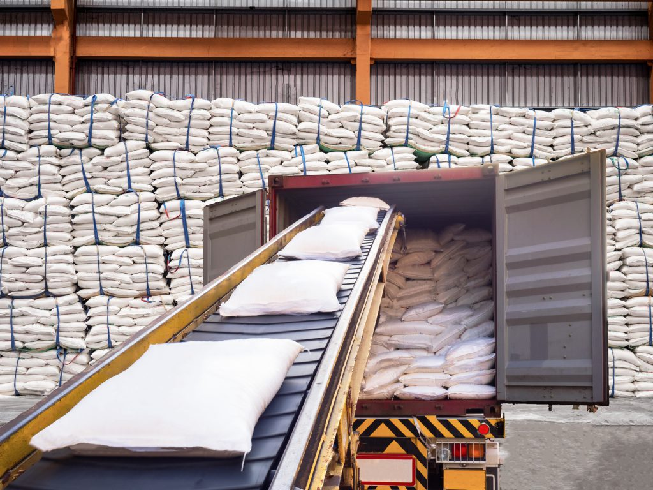Mr. Amarin Jitnathum/Shutterstock.com

Sacks of sugar being processed for export will be influenced by a variety of forces, trends and shocks.

**The UK food system can be more resilient**

The GFS-FSR programme will improve understanding of how the UK food system can increase its resilience to shocks and stresses. The programme will fund and coordinate a number of collaborative research projects to produce new evidence and recommendations for policy and practice. This will help create a more efficient and resilient UK food system in a changing world.